| **Quality First Teaching - general classroom practice** | **Comments** | **Date – in place?** | **Follow up date – is in place** |
| --- | --- | --- | --- |
| Is/Are the …. |
| * classroom well organized and labelled (with visual cues/pictures)? |  |  |  |
| * differentiation varied and structured? |  |  |  |
| * lesson structure clear with learning objectives presented orally and visual? |  |  |  |
| * instructions given in small chunks with visual cues? |  |  |  |
| * understanding checked by asking pupils to explain what they have to do? |  |  |  |
| * understanding demonstrated in a variety of ways? |  |  |  |
| * a range of groupings within the class including some random pairing activities? |  |  |  |
| * activities and listening broken up with breaks for more kinaesthetic activities? |  |  |  |
| * feedback comments more positive than negative? |  |  |  |
| * praise specific and named? |  |  |  |
| * memory supported by explicit demonstration and modelling of memory techniques? |  |  |  |
| * classroom assistants planned for and used to maximize learning? |  |  |  |
| * pupils clear about what is expected – use of ‘WAGOLL’ – what a good one looks like – examples? |  |  |  |
| * relationships with CYP fostered and developed positively? |  |  |  |
| Knowing the child   * Identify, celebrate, and build on the child’s strengths. * Get to know the child well through careful observation, and reflecting on what went well/didn’t go well and why. * Consider the child’s basic needs (environment, food, drink, toilet, sleep, medical etc.) * Pre-empt situations which individual children may find difficult – avoid problems happening. |  |  |  |
| Environment   * Provide a quiet, calm, safe place to go to when needed. * Remove distractions (Sensory – lighting, temperature, noise, visual distractions – cluttered displays, clutter. Social – people) * Be organised – have appropriate resources ready, (visual, kinaesthetic and auditory). |  |  |  |
| Routines   * Keep things predictable, have routines which don’t change too often. * Allow for “sensory breaks” between activities. * Provide transition activities to support the children to transfer their focus from one set of expectations to another eg when coming into school/after play. * Visual, regularly referred to, reward systems – what would the children value as a reward? * Regular reminders of rules, rewards and consequences – have visual displays and refer to them regularly. * Timers – give a countdown to changes of activities. * “Catch ‘em being good” – reward the positives. OFTEN. |  |  |  |
| Language   * Use visual cues to aid understanding. * Have a visual timetable so the children know what happens next. * Make instructions clear, and ensure the children have understood. * When speaking to children say the child’s name first to get their attention. * Ensure the child processes the whole sentence, if not, find out whether they remember the first or last thing heard, and ensure the most important instruction is put in the right part of the sentence eg Chris, put coat on, time to play outside, or Chris, outside play, coat on. * Pre teach any new language which may be needed eg for a specific topic. |  |  |  |
| Adults should:   * Model to the children what you want them to do. * Be a positive role model for good behaviour. * Find opportunities to teach specific skills eg turn taking, sharing, understanding facial expressions and body language, understanding how other people feel. * Interact with the children, play with them, teach them skills, comment on what they say and do, acknowledge their feelings and achievements. * Not put children into situations they are unable to deal with without supporting them and teaching them the skills they need. |  |  |  |

**General good practice proactive strategies to support pupils in schools and settings**

**Every teacher a teacher of SEN**

Once this is embedded, good practice is to **identify the barriers, reflect on the reasons why** (if possible, with colleagues) and **respond with interventions *within* the classroom.**

**The Code of Practice states:**

*All pupils should have access to a broad and balanced curriculum. The National Curriculum Inclusion Statement states that teachers should set* ***high expectations for every pupil****, whatever their prior attainment. Teachers should use appropriate assessment to set targets which are deliberately ambitious. Potential areas of difficulty should be identified and addressed at the outset. Lessons should be planned to address potential areas of difficulty and to remove barriers to pupil achievement. In many cases, such planning will mean that pupils with SEN and disabilities will be able to study the full national curriculum.*

***The first response to (less than expected) progress should be high quality teaching targeted at pupils’ and students’ areas of weakness****.*

*Making higher quality teaching normally available to the whole class is likely to mean that fewer pupils will require additional support. Such improvements in whole-class provision tend to be more cost effective and sustainable.*

The following is adapted from SendGateway [*SEN support: research evidence on effective approaches and examples of current practice in good and outstanding schools and colleges*](https://www.sendgateway.org.uk/resources.sen-support-research-evidence-on-effective-approaches-and-examples-of-current-practice-in-good-and-outstanding-schools-and-colleges.html)and is a brief overview of research from the Sutton Trust and EEF on effectiveness of high quality teaching strategies **for primary KS 1 and 2, Secondary KS3 and 4, as well as post 16**

| **Strategy** | **Most useful for any Key Stage** | **What is the strategy?** | **How strong is the evidence?** | **Further information** |
| --- | --- | --- | --- | --- |
| Teaching planning, monitoring  and evaluation of  pupils’ own work | Learning difficulties,  attention difficulties  **1,2,3,4, +16** | Students are given explicit guidance in how to plan their writing, monitor their understanding and evaluate their own performance, encouraging them to reflect upon their understanding. | **Good** evidence that this improves attainment. | Research:  EEF-Sutton Trust  Teaching and Learning  Toolkit: Metacognition  strategies;  Gureasko-Moore et al. 2006 |
| Provide regular practice  of information that has  already been taught, interleaved  with new material | All pupils and students  **1,2,3,4, +16** | Pupils and students are encouraged to practice knowledge even when it is known, to ensure it is automatically and fluently recalled. | **Good** evidence that extensive practice is a key element in successful teaching. | Research: Swanson &  Hoskyn (2001); Chard et  al (2002) |
| Encourage regular physical  activity in the school  routine | Attention difficulties  **1,2,3,4,+16** | Carrying out physical activity, whether moderate physical exercise or lower intensity like yoga, as part of the school day | **Good** evidence that this improves attention and behaviour in class. | Research:  Reeves et al (2016); Verret  et al (2012); Jensen  & Kenny (2012) |
| Explicit teaching of  reading comprehension  strategies | Literacy needs **1,2,3,4, +16** | Teaching a range of techniques to enable pupils and students to understand the meaning of what is written, including inferring meaning from context, identifying key  points and monitoring their own understanding. | **Good** evidence that this improves comprehension of connected text. | EEF-Sutton Trust  Teaching and Learning  Toolkit: Comprehension  strategies |
| Reducing levels of noise in  the classroom | Attention difficulties,  hearing impairment  **1,2,3,4, +16** | Reduce sound levels with acoustic panelling or other sound deadening materials. | **Moderate** evidence that attainment of pupils and students with SEND is more affected by classroom noise than their peers. | Dockrell & Shield, 2006 |
| Use of teaching assistants | All pupils and students  **1,2,3,4, +16** | Teaching assistants support the work of the teacher by working with individual pupils, small groups or take the larger group to allow the teacher to work with a small group | **Good** evidence that teaching assistants can be effective when they are well trained and have a clearly designated role. | Research: EEF Review |
| Peer tutoring | All pupils and students, particularly low attaining  Pupils  **2,3,4,+16** | Pupils and students work in pairs or small groups often mixed ability or mixed age groups. | **Good** evidence that peer tutoring improves learning, but effects are largest when children are taught explicit strategies for supporting each other. | Research: EEF-Sutton  Trust Review |

|  |  |  |  |  |
| --- | --- | --- | --- | --- |
| **Strategy** | **Most useful for Key Stage 1 and 2** | **What is the strategy?** | **How strong is the evidence?** | **Further information** |
| Encourage the use of  memory strategies | Learning difficulties,  attention difficulties  **1,2** | Encourage pupils and students to use strategies to improve their memory. These include chunking, mnemonics and linking audio and visual knowledge. | **Good** evidence that this is effective in improving memory. | Research: Wolgemuth et  al, 2008 |
| Promoting language  awareness and communication  strategies in the  classroom | Language difficulties,  attention difficulties  **1,2** | Complete an audit working out how well the classroom supports communication, and how practice could be improved. | **Good** evidence that the checklist is based on practice examples in classrooms.  Promising evidence of the effect of using the checklist. | Resource:  Communication Supporting  Classroom  Observation Tool  Research:  Dockrell et al, 2012 |
| Systematic phonics based  reading instruction | Literacy needs **1,2** | Systematically teaching pupils and students the links between the sounds of spoken language (phonemes) and letters and words. | **Good** evidence that this improves literacy outcomes. | Research: EEF phonics  report |
| Encourage pupils and  students to work towards  specific goals which are  appropriate for them | All pupils and students **1,2** | In a range of different fields, it is more effective to focus on meaningful task goals rather than focusing on basic underlying skills.  For example, a focus on improving handwriting is more effective than teaching the underlying sensorimotor skills. | **Moderate** evidence that this principle holds true. | Research:  Kearns & Fuchs, 2013;  Schaaf et al 2014; Santangelo  & Graham 2016;  Rodger & Brandenberg, 2009 |

|  |  |  |  |  |
| --- | --- | --- | --- | --- |
| **Strategy** | **Most useful for Key Stage 3 and 4 or above** | **What is the strategy?** | **How strong is the evidence?** | **Further information** |
| Encourage the use of  memory strategies (e.g.  chunking, mnemonics) | Learning difficulties,  attention difficulties  **3,4,+16** | Chunking involves joining individual pieces of information into larger units – e.g. remembering 1-2-5-7-7-3 as 125 773.  Mnemonics involve teaching rhymes or patterns for remembering information (e.g. ‘Richard of York gave battle in vain’ for the colours of the rainbow). | **Good** evidence that this is effective in improving memory. | Research: Wolgemuth et  al, 2008 |
| Promotion of mathematical  resilience | Numeracy needs **3,4, +16** | Pupils and students are made aware that becoming successful at maths sometimes involves struggle in different areas, valuing mathematics and improving your knowledge of it. | **Promising** evidence that this improves mathematical outcomes. | Mathematical Resilience  Research:  Johnstone-Wilder et al,  2010 |
| Forming support groups | Emotional difficulties  **2,3,4, +16** | Helps students develop interpersonal skills, emotional intelligence, emotional regulation, forming and maintaining good relationships, empathy, self-esteem and confidence, and a positive attitude towards learning. | **Promising** evidence that this helps to develop good interpersonal skills. | Research: Mowat (2010) |

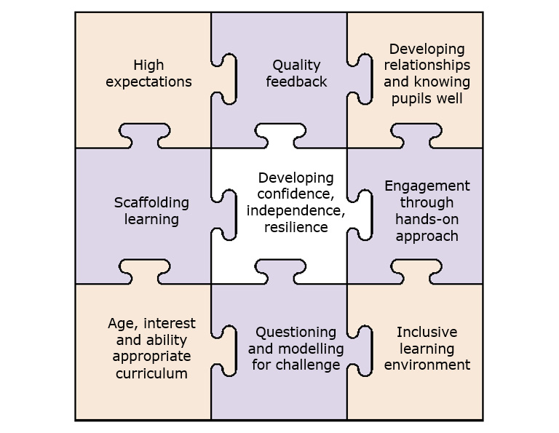Natalie Packer Teacher’s Guide to SEN (2017)